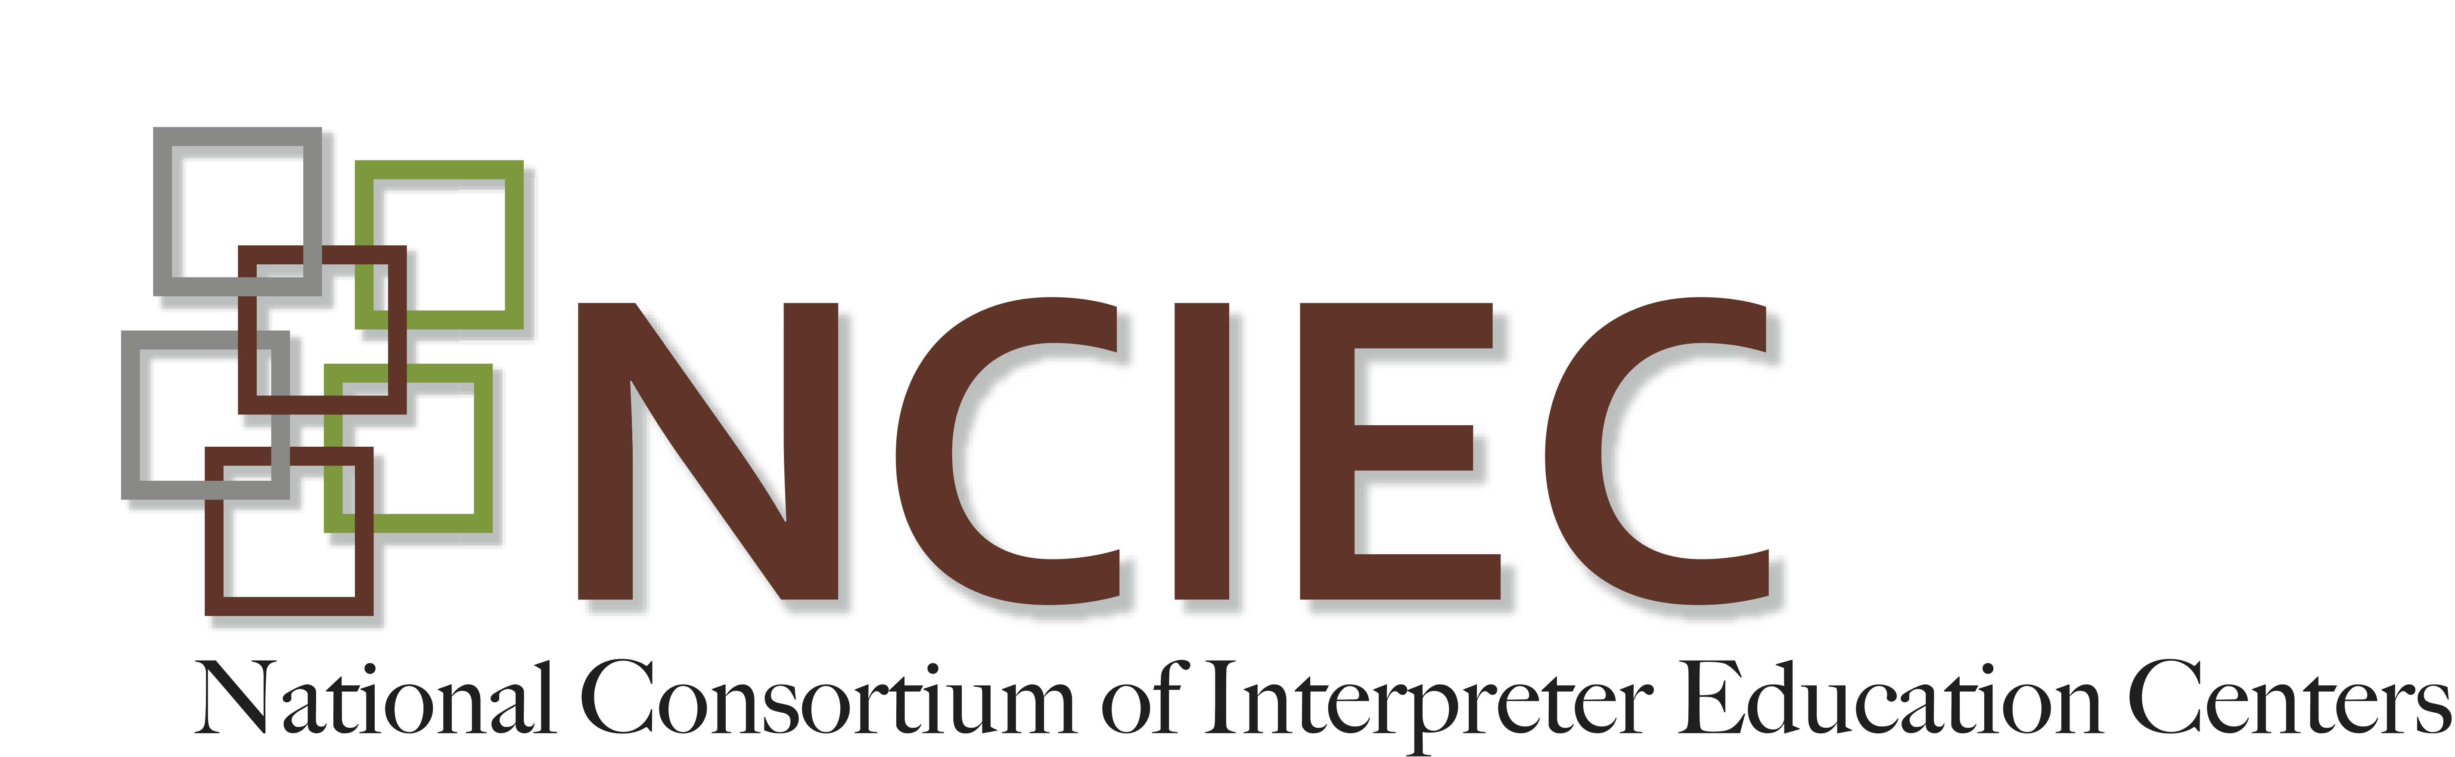

VR: Faces of Deaf Consumers

Student Welcome

Link to ASL Welcome:

http://youtu.be/euEJvX6XLk4
Welcome to the National Interpreter Education Center (NIEC) online module, Faces of Deaf Vocational Rehabilitation Consumers. This resource is designed to expose interpreting education students to VR and to foster interest in working this setting. The module contains information on the needs of consumer exclusively. Though a great deal of interpreting that occurs in VR settings includes Deaf professionals, this module does not address this unique population.
A comprehensive overview of the diversity of Deaf VR consumers is not possible in this module. Our intent is to provide a primer on some of the salient characteristics of these consumers. The focus of the module is on the unique communication needs of Deaf individuals particularly those who may have limited language proficiency, the impact of deaf education on the communication of Deaf individuals and briefly addresses the challenge of Deaf individuals who may have a disability or are immigrants from non-ASL using countries.
The three main components of the module are an overview of the factors to consider when describing the identity and communication skills of Deaf individuals, an overview of the types of educational settings currently available in the US for Deaf children and the importance of an interpreter’s ability to self-assess his or her language and interpreting skills when contemplating accepting an interpreting assignment. Each of these components includes a short reading and a PowerPoint presentation synthesizing the reading and related activities.
The module also includes a pre and post-test to gauge the extent of learning as a result of participating in this module.
Copyright © 2013 by the National Consortium of Interpreter Education Centers (NCIEC).

This NCIEC product was developed by the National Interpreter Education Center (NIEC) at Northeastern University. Permission is granted to copy and disseminate these materials, in whole or in part, for educational, non-commercial purposes, provided that NCIEC is credited as the source and referenced appropriately on any such copies.

