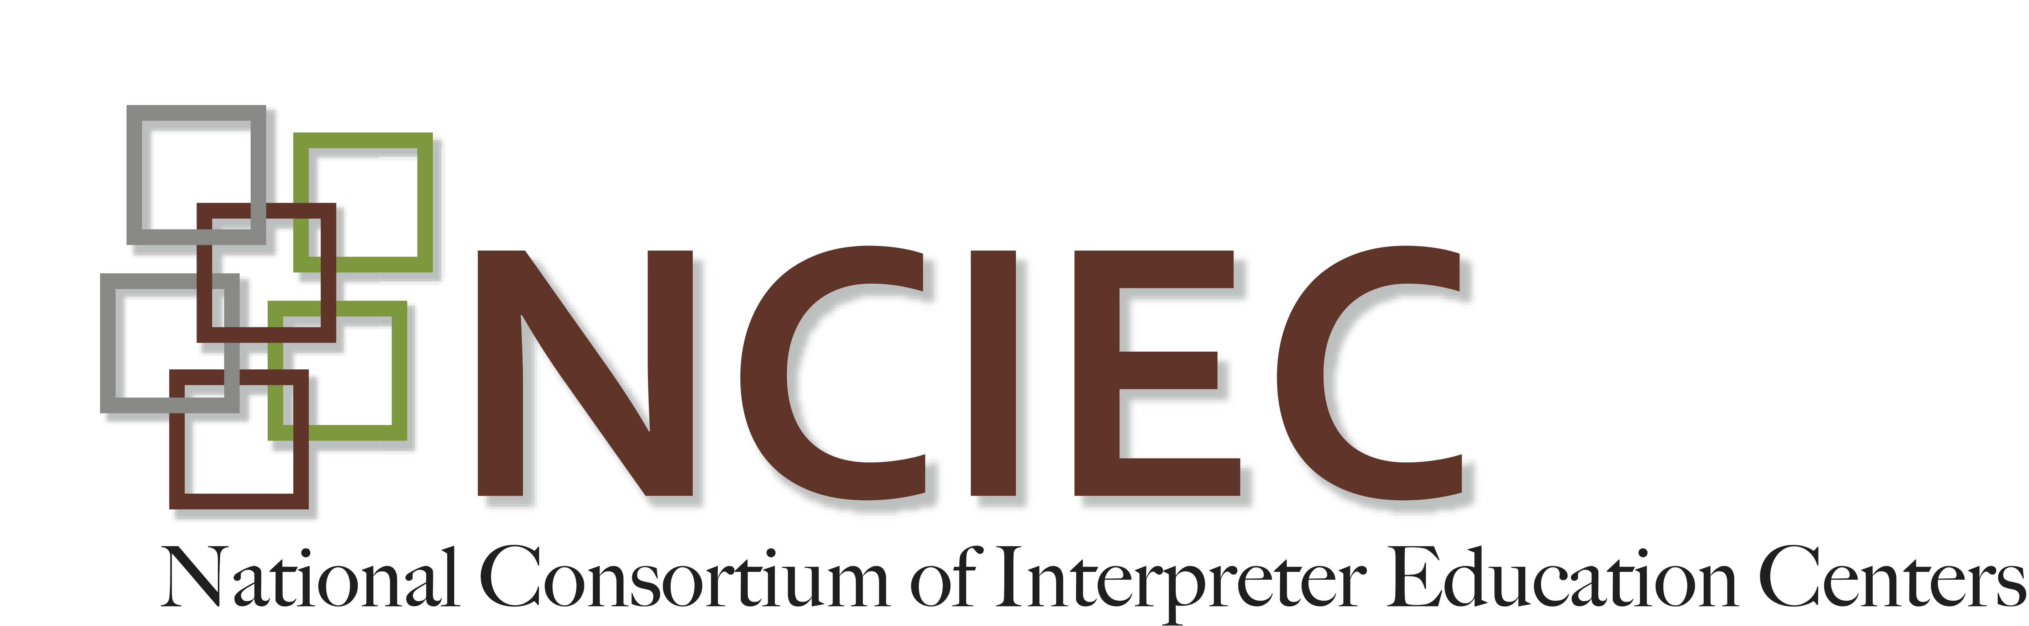

VR: Faces of Deaf Consumers

Faces of VR consumers Student Pre-Test

- Holcomb identifies seven identity categories within the Deaf community. Please name three of these identities.

- In the Consumer Assessment Identifying Language, Culture and Communication Style PowerPoint presentation by Jim Lipsky, he identifies eight communication styles in the Deaf community. Please name three of these styles:

- The Report of the Study Group on Serving Individuals who are Low-Functioning Deaf identifies six characteristics of people who are Low-Functioning. Which of the characteristics below is not one of the Study Group findings:

Inadequate communication skills
Vocational deficiencies
Deficiencies in behavioral adjustment
Independent Living Skills deficiencies
Educational deficiencies
Having hearing parents who do not use ASL

- The Individuals with Disabilities Education Act (IDEA) had a dramatic effect on Deaf Education. By emphasizing the Least Restrictive Environment, many school districts defined this as local schools instead of traditional state residential schools for the deaf. What impact did this change have on the field of educational interpreting?

- Name three communication approaches used in Deaf Education:

- Dean & Pollard identify four areas of consideration for application of the Demand-Control Schema represented by the acronym, EIPI. Name these four areas:

- Deaf Interpreters employ which of the following techniques:

Intra-lingual interpretation
Visual communication techniques
Strategies for communicating with Deaf people with limited English fluency
All of the above

- Which of these steps may an interpreter use to ensure an effective interpretation after conducting a pre-assignment assessment:

Use consecutive interpretation
Request a hearing interpreter team
Request a deaf interpreter team
Decline to interpret the assignment
All of the above

Copyright © 2013 by the National Consortium of Interpreter Education Centers (NCIEC).

This NCIEC product was developed by the National Interpreter Education Center (NIEC) at Northeastern University. Permission is granted to copy and disseminate these materials, in whole or in part, for educational, non-commercial purposes, provided that NCIEC is credited as the source and referenced appropriately on any such copies.

