VR 101: History, System & Process

The Vocational Rehabilitation Act
This page shares a presentation focusing on Vocational Rehabilitation act. The video includes ASL interpretation. Below that, there is a link to view the original presentation on the website of the Minnesota Council on Developmental Disabilities. Below that, you can read the English transcripts of the presentation. Use whatever format is most beneficial for your learning.

Questions for Reflection:
- What do each of the 7 Titles of the VR Act cover?
- Why do you think Carl Suter described this act as a model for the rest of the world?
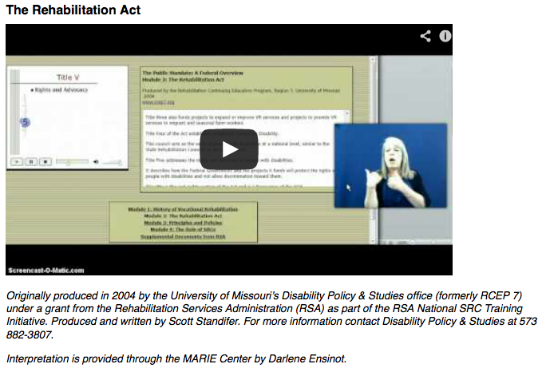
To access the presentation click here: http://youtu.be/O8YsIhcuvzw
Originally produced in 2004 by the University of Missouri’s Disability Policy & Studies office (formerly RCEP 7) under a grant from the Rehabilitation Services Administration (RSA) as part of the RSA National SRC Training Initiative. Produced and written by Scott Standifer. For more information contact Disability Policy & Studies at 573 882-3807.
Interpretation is provided through the MARIE Center by Darlene Ensinot.

