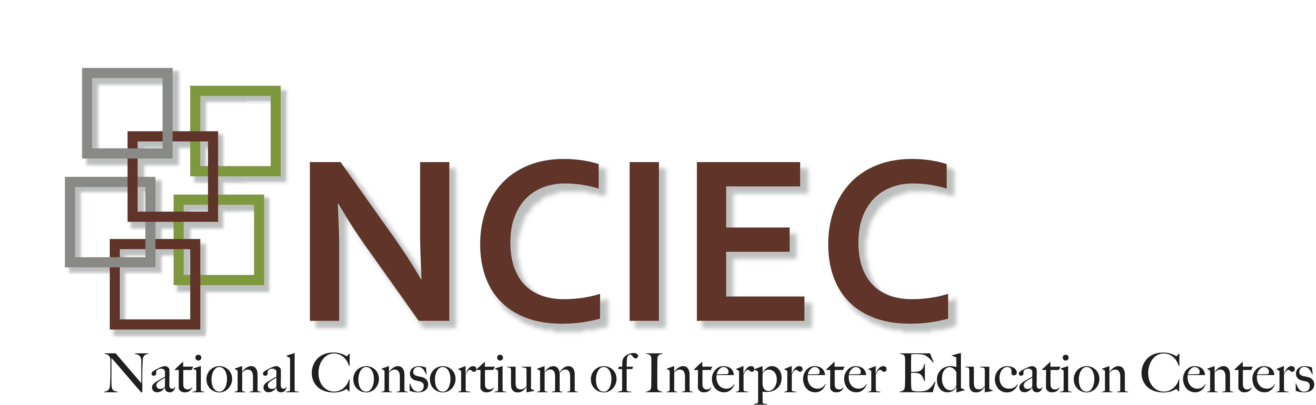

Allyship Behavior Development: DISCUSSION GUIDE

Here are some discussion questions to use after teachers cover the Allyship Behavior Development readings.

Online Resource for Teachers: Asking Questions to Improve Learning
(http://teachingcenter.wustl.edu/strategies/Pages/asking-questions.aspx)

Student Reflection Questions:

- At what point are you currently in the development of allyship behaviors?
  - Where do you want to be?
  - How are you going to get there?

- Allyship is about listening and valuing personal narratives. As an ally, how will you remind yourself to put forth a sincere effort to listen to the personal narratives?

- Trust is something earned through concerted action. What will you do to seek such an important trait with those you work with?

- Ensuring that you are becoming an ally is not the responsibility of others. It is not a passive process. This is a life-long process in which you have to be fully engaged and be mindful of your thoughts and behaviors in terms of allyship. What will you do to continue your growth as an ally?

- How will you avoid taking the spotlight on your activity as an ally and ensure that your decisions and reasons are grounded in scholarship and lived experiences of Deaf community members?

Copyright © 2014-2016 by the National Consortium of Interpreter Education Centers (NCIEC).

This NCIEC product was developed by the National Interpreter Education Center (NIEC) at Northeastern University. Permission is granted to copy and disseminate these materials, in whole or in part, for educational, non-commercial purposes, provided that NCIEC is credited as the source and referenced appropriately on any such copies.

