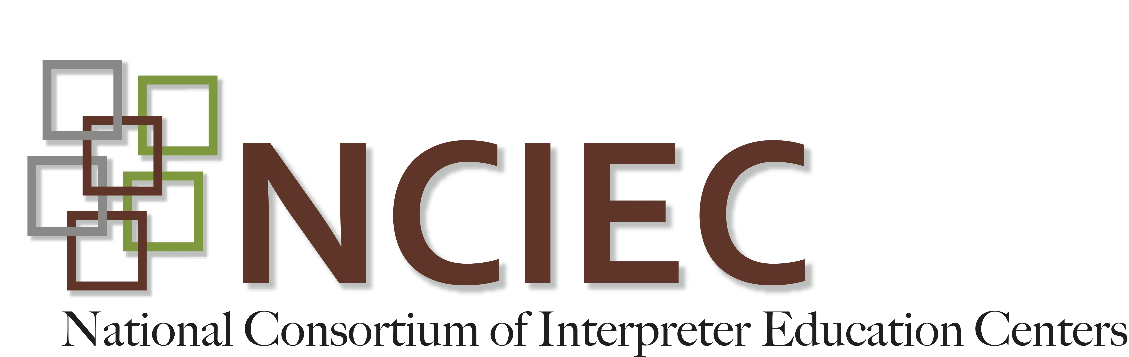
DEAF INTERPRETER-HEARING INTERPRETER TEAMS
Unit 1-Student Activity:

Instructor Guide
Unit One - Introduction to Deaf-Hearing Interpreter Team
Video Activity Sheet

VIDEO: GURIEC Panel "Deaf/Hearing Interpreting Teams Training" April 27, 2012
http://webcast.gallaudet.edu/?id=97
INSTRUCTIONS: You will watch two short segments from this 2 hour video and then answer questions:
1. Segment One (8 minutes): Time mark - 03:46 to 11:48 - Opening
2. Segment Two (7 minutes): Time mark - 56:25 to 1:03:## - introduction of panel members.

Questions:

1. What is the background for each person? Include names, DI or HI, how long they have worked as interpreters, and what kind of DI-HI training did they receive?

2. What are your initial thoughts on the panelist’ comments? What surprised you?

Copyright © 2013-2016 by the National Consortium of Interpreter Education Centers (NCIEC).
This NCIEC product was developed by the National Interpreter Education Center (NIEC) at Northeastern University. Permission is granted to copy and disseminate these materials, in whole or in part, for educational, non-commercial purposes, provided that NCIEC is credited as the source and referenced appropriately on any such copies.

