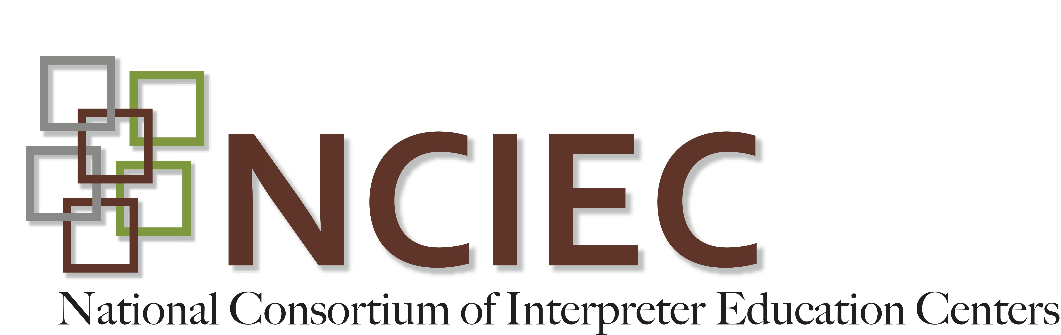
DEAF INTERPRETER-HEARING INTERPRETER TEAMS
Instructor Guide
Unit One - Introduction to Deaf-Hearing Interpreter Team
Video Activity Sheet

VIDEO: GURIEC Panel "Deaf-Hearing Interpreting Teams Training" April 27, 2012
http://webcast.gallaudet.edu/?id=97
INSTRUCTIONS: You will watch two short segments from this 2 hour video and then answer questions:
1. Segment One (8 minutes): Time mark - 03:46 to 11:48 - Opening
2. Segment Two (7 minutes): Time mark - 56:25 to 1:03:## - introduction of panel members.
Questions:

1. What is the background for each person? Include names, DI or HI, how long they have worked as interpreters, and what kind of DI-HI training did they receive?

Possible answers:
Steven Walker: DI, at least twenty years working as interpreter, “like Carolyn, I was dumb to say yes to everything just to work with HIs for different events.” Steven has worked in different settings, including legal and law enforcement. He didn’t receive any training but rather learned how to work in DI-HI team on-the-job.
Beth Gregorich: HI, at least 25 years of experience, working with DIs for 15 years. Tends to work in DI-HI team for Deaf consumers with language challenges. Also works in DI-HI teams for police, court, etc. First training received in San Diego 4 or 5 years ago but like Steven, most of her training was on-the-job.
Kari Bahl: HI, working for 7 years, with DIs for 5 years. Works predominantly with DIs in classroom setting where there is a Deaf-Blind student and hearing teacher. She does not directly feed DIs, but DIs access the hearing teacher’s lecture from her interpretation to the other deaf students. Kari usually works in a DI-HI team for law enforcement or courtrooms and anything that involves children. Kari mentions that, as with Steven and Beth, her training was on-the-job. Kari graduated with a MA in Interpretation. During her MAI program, Carolyn did come to her class to give a presentation about DI-HI teams and practiced with Deaf classmates briefly so that could be counted as training.
Gino Gouby: Worked as an interpreter since 1999 (13 years total), in Arizona usually in legal setting such as courtroom and law enforcement. Majority of work in DI-HI team, usually in courtrooms for Mexicans migrating to the USA. In DC, Gino works in DI-HI teams in the same setting: court and police. More recently Gino’s work has included conference setting where he is on stage and the HI feeds as translates into International Signs (old label: Gestuno). Training received: same-- on-the-job & trial-and-error. Did go to the San Diego workshop led by Carolyn Ressler. Gino mentions that he notices an increase in DI-HI training workshops being offered today compared to few years ago.

2. What are your initial thoughts on the panel comments? What surprised you?

Possible Answer:
This is the students’ chance to reflect and build on what they have read; they could answer anything. After reflecting with them on their answers, here are additional questions to consider if they have not touched on these areas:

- What do you think about the training that the DI-HI teams? (Point out the lack of training.)
- The DIs have worked as interpreters for 10+ years. Is this a surprise to you? Why or why not? (They may have thought CDIs, as a field, is relatively new, maybe barely 5 years.)
- Why do you think Steve Walker states that he was dumb to take any assignment in the beginning of his career? (Lack of training. Didn’t really understand the repercussions of his actions - if he misinterpreted. Lack of knowledge on how a DI-HI team should work together.)
- What do you think of the fact that all four panel members work in DI-HI team for legal or law enforcement settings? (Even though there isn’t much training for DIs they are going into the most sensitive areas that have the biggest consequences.)

Copyright © 2013-2016 by the National Consortium of Interpreter Education Centers (NCIEC).
This NCIEC product was developed by the National Interpreter Education Center (NIEC) at Northeastern University. Permission is granted to copy and disseminate these materials, in whole or in part, for educational, non-commercial purposes, provided that NCIEC is credited as the source and referenced appropriately on any such copies.

