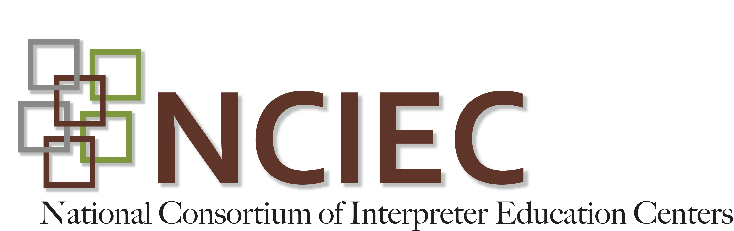
DEAF INTERPRETER-HEARING INTERPRETER TEAMS
Instructor Guide
Unit 2: Making a case for a DI-HI Team - Assessment
Quiz
- DIs are native or native-like users of ASL, describe one way in which this language fluency contributes to their effectiveness when working in a DI-HI team.
Possible Answers:
  - Because DIs have had lifelong experiences and exposure to Deaf people with different language backgrounds and with varying cognitive abilities, they been exposed to and have developed familiarity of countless variations and dialects of ASL.
  - From this foundation of language variation and exposure, DIs are able to recognize educational, cognitive, physiological, and sociolinguistic factors and communication needs likely to influence interpretation.
  - DIs can draw from this acquired language base to come up with alternative visual communication strategies that are creative and flexible enough to meet a variety of consumers’ needs.

- DIs have in many ways functioned as informal interpreters all their lives. Provide at least two examples of informal interpreting experiences DIs may have experienced prior to becoming a professional DI.
Possible Answers:
  - For their family members assisting in bridging the communication gaps in a number of everyday life interactions.
  - In educational settings for their peers when educators were not fluent users of ASL.
  - For Deaf immigrants who were not fluent in ASL assisting them with a variety of documents, forms, issues and situations.

- DIs have firsthand knowledge of the Deaf-life experience that provides them with an intrinsic understanding cultural norms, values and constructs of the Deaf community. Explain one way in which this cultural experience influences their interpreting work.
Possible Answers:
  - DIs are able to negotiate and culturally mediate interpreted interactions where both Deaf cultural and hearing cultural norms and assumptions exist.
  - DIs bring an understanding of what it’s like to be a member of a minority group having experienced oppression, discrimination and paternalistic attitude.
  - Having personally experienced all that membership into the Deaf culture brings, DIs are able to recognize these cultural dynamics and work from this underlying cultural framework.

- Describe 3 ways a DI’s formative skills and experiences may benefit a Deaf consumer.
Possible Answers:
  - His/her language use will be accurately assessed to determine a target language/communication form.
  - The DI will use variety of strategies to draw out information and seek clarification of meaning.
  - Potential gaps (e.g. informational, experiential, educational, visual, protocol, cognitive, memory, cultural, or frame of reference) relative to the particular interaction or setting will be identified in order to determine a target language/communication strategy consistent with the experiential and linguistic framework of the Deaf consumer and appropriate to situational protocol.
  - S/he will be able to express themselves more freely without concern for misunderstanding and/or misinterpretation.
  - S/he can be less concerned about cultural misunderstandings knowing that the DI shares his/her culture. The DIs’ mere presence will curtail a potential feeling of isolation.
  - S/he may experience less stress from the positive psychological impact of DI’s presence due to a sense of sameness they share.
  - The DI will act as a communication advocate to ensure understanding and communication
  - The DI will apply his/her understanding and life experience of the history and significance of oppression in the Deaf community in analysis of power relationships among participants within the interpreted interaction in order to determine how the consumer’s position within the power dynamic might influence interpreting decisions or strategies.

- Describe 3 ways a DI’s formative skills and experiences may benefit both the Deaf and hearing consumers.
Possible Answers:
  - Communication will be accurate and clear resulting in optimal understanding
  - There is greater efficiency of language access resulting in a more cost effective exchange.
  - The interaction will be monitored to determine whether interpreting is effective and when it might be appropriate to stop the proceedings and offer appropriate alternative resources ensuring clarity of communication.
  - Appropriate clarification of culturally based information will occur and will result in a reduced number of cultural misunderstandings that occur.

- Describe 3 ways a DI’s formative skills and experiences may benefit the HI.
Possible Answers:
- From seeing their interpretation re-interpreted by the DI and thereby having an immediate opportunity to see a different way to construct the English message, learning new vocabulary and grammatical features of ASL.
- From having a second opportunity to view the source information to ensure conveyance of the full integrity of the message.
- By having more confidence in the interpreting work being effective and equivalent.
- From being part of a team where both interpreters bring their essential skills and experiences to the work to verify meaning, gather clarifying information, manage information flow within the team, and effect a mutual monitoring process in the co‐construction of complete and accurate interpretation for all consumers involved
- From learning new culturally normative ways to construct ASL messages

Copyright © 2013-2016 by the National Consortium of Interpreter Education Centers (NCIEC).
This NCIEC product was developed by the National Interpreter Education Center (NIEC) at Northeastern University. Permission is granted to copy and disseminate these materials, in whole or in part, for educational, non-commercial purposes, provided that NCIEC is credited as the source and referenced appropriately on any such copies.

