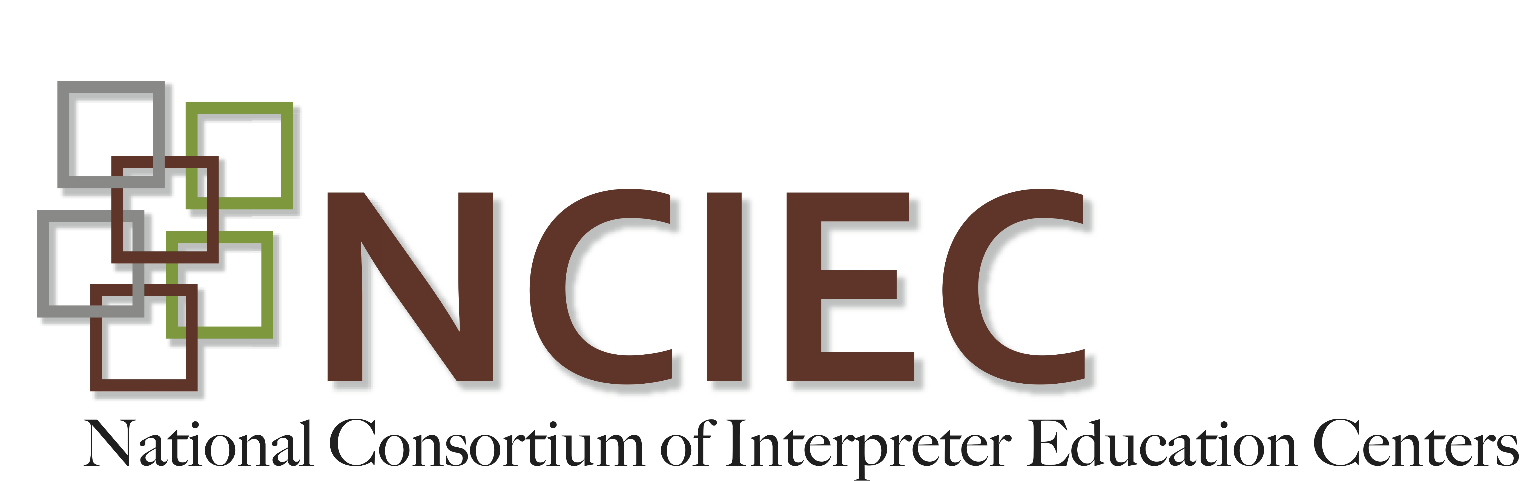
DEAF INTERPRETER-HEARING INTERPRETER TEAMS
Unit 2 – Making a case for a Deaf Interpreter-Hearing Interpreter (DI-HI) Team
Introduction
If you have not yet worked with a DI or seen a DI at work you might wonder how their work in a DI-HI team can enhance the overall effectiveness of the interpretation and of the communication exchange. Though there are settings and consumers that require a DI-HI team to provide equal access under the law, this unit is designed to identify and describe the formative experiences that DIs bring to the interpreting task. You will learn how these experiences not only provide that equal access but have additional benefits to the hearing consumer, the Deaf consumer, and the HI as well.

The DIs Foundational skills and experiences
As Deaf people, DIs have acquired foundational skills and experiences that positively contribute to their work in a DI-HI team. While a number of these skills and experiences have been identified as being beneficial, this unit will address three particular DI areas of expertise that positively contribute to an interpreted event: 1) DIs are native or native-like users of ASL, 2) DIs have lifelong interpreting experience, and 3) DIs are members of the Deaf community/culture.

1. As native or native-like users of ASL, DIs have had lifelong experiences and exposure to Deaf people with different language backgrounds and with varying cognitive abilities. These experiences have afforded them opportunities to be exposed to and interact with individuals using countless variations and dialects of ASL. From this foundation of language variation and exposure, DIs are able to recognize educational, cognitive, physiological, and sociolinguistic factors along with communication needs likely to influence interpretation. Also, DIs can draw from this acquired language base to come up with alternative visual communication strategies that are creative and flexible enough to meet a variety of consumers’ needs.

2. Well before DIs are formally given the title of “DI,” they have already accumulated years of interpreting experience. They have, in fact, been functioning as interpreters informally all of their lives. These interpreting experiences span a multitude of settings within varying language environments and involve an infinite list of situational topics.
The NCIEC Deaf Interpreter Work Team (2010) in their report on the competencies of Deaf Interpreters describes some of these formative interpreting experiences where DIs have functioned as informal interpreters. Below is a list of some of these informal interpreting experiences identified by DIs who participated in these focus group discussions:

- For their family members, assisting in bridging the communication gaps in a number of everyday life interactions.
- In educational settings, for their peers when educators were not fluent users of ASL.
- For Deaf immigrants, who were not fluent in ASL, assisting them with a variety of documents, forms, issues, and various settings.

3. As members of the Deaf community/culture, DIs have firsthand knowledge of the Deaf-life experience. They have an intrinsic understanding of cultural norms, values, and constructs of the Deaf community. Through this understanding, DIs are able to negotiate and culturally mediate interpreted interactions where both Deaf cultural and hearing cultural norms and assumptions exist.

While cultural membership has immeasurable benefits, it also can come with adverse experiences when the culture is perceived as being outside the majority. Oppression, discrimination and paternalistic attitudes are common experiences among members of Deaf communities. Having personally experienced all that membership into Deaf culture brings, DIs are able to recognize these cultural dynamics and work from this underlying cultural framework.

What about Hearing Interpreters of Deaf Parents (IDP)/Children of Deaf Adults (CODAs)/Hearing Heritage Signers?
Because hearing children of Deaf adults may also be heritage or native/native-like users of ASL, may have had early life experiences interpreting informally, and may be considered members of Deaf communities, one might wonder whether or not a hearing IDP and a DI are one in the same. While it is important to recognize the unique experiences and skills hearing IDP interpreters bring to the interpreting team, it is also important to note that there are both organic and experiential differences between a hearing heritage signer and someone who is Deaf. Many of these differences stem from the life experiences one has as a Deaf, visually-orientated individual. Lived experiences from this visu-centric orientation impact neurological development in a number of ways. Bahan (2004) describes in a study how this Deaf way of being created a consistent advantage in the ability of Deaf subjects to perform certain visual tasks. Driven by the innate need to communicate, Deaf people are able to “see far beyond the capacity of ordinary eyes” (Bahan, 2004, p. 30). While hearing IDPs may live between two worlds (the Deaf world and the hearing world), DIs bring the essence of the DEAF-WORLD way of being into their interpreting work in ways that only someone who is Deaf is able to do.

Benefits of a DI
The formative skills and experiences described above provide a number of attributes that DIs bring to the interpreted event. These attributes benefit all parties involved: Deaf consumers, hearing consumers, and HIs. Below are some ways DIs enhance the communication and overall experience for all participants involved.

1. Deaf consumers can be confident that:
a. Their language use will be accurately assessed to determine a target language/communication form.
b. The DI will use variety of strategies to draw out information and seek clarification of meaning.
c. “Potential gaps (e.g. informational, experiential, educational, visual, protocol, cognitive, memory, cultural, or frame of reference) relative to the particular interaction or setting will be identified in order to determine a target language/communication strategy consistent with the experiential and linguistic framework of the Deaf consumer and appropriate to situational protocol” (National Consortium of Interpreter Education Centers, 2010, p. 5).
d. They will be able to express themselves more freely without concern for misunderstanding and/or misinterpretation.
e. They can be less concerned about cultural misunderstandings knowing that the DI shares his/her culture. The DI’s mere presence will curtail a potential feeling of isolation.
f. They may experience less stress from the positive psychological impact of the DI’s presence due to a sense of sameness they share.
g. The DI will act as a communication advocate to ensure understanding and communication.
h. “The DI will apply [their] understanding and life experience of the history and significance of oppression in the Deaf community in analysis of power relationships among participants within the interpreted interaction in order to determine how the consumer’s position within the power dynamic might influence interpreting decisions or strategies” (National Consortium of Interpreter Education Centers, 2010, p. 5).
2. Both hearing and Deaf consumers can be confident that:
a. Communication will be accurate and clear resulting in optimal understanding.
b. There is greater efficiency of language access resulting in a more cost effective exchange.
c. “The interaction will be monitored to determine whether interpreting is effective and when it might be appropriate to stop the proceedings and offer appropriate alternative resources ensuring clarity of communication” (National Consortium of Interpreter Education Centers, 2010, p. 6).
d. Appropriate clarification of culturally based information will occur and will result in a reduced number of cultural misunderstandings that occur.

3. The hearing interpreter can benefit:
a. By having more confidence in the interpreting work being effective and equivalent.
b. From being part of a team where both interpreters bring their essential skills and experiences to the work to verify meaning, gather clarifying information, manage information flow within the team, and affect a mutual monitoring process in the co‐construction of complete and accurate interpretation for all consumers involved.
c. From learning new culturally normative ways to construct ASL messages.
d. From seeing their interpretation re-interpreted by the DI and thereby having an immediate opportunity to see a different way to construct the English message and learning new vocabulary and grammatical features of ASL.
e. From having a second opportunity to view the source information to ensure conveyance of the full integrity of the message.

References
Bahan, B. (2004). Memoir upon the formation of a visual variety of the human race. Deaf Studies Today!, 1, 17- 35.
National Consortium of Interpreter Education Centers. (2010). Toward effective practice: Competencies of the Deaf Interpreter. Boston, MA: NCIEC Deaf Interpreter Work Team. Retrieved fromhttp://www.diinstitute.org/wp-content/uploads/2012/07/DC_Final_Final.pdf.

Suggested Resources
Bentley-Sassaman, J. (2010). Experiences and training needs of Deaf and hearing interpreter teams. (Unpublished doctoral dissertation). Walden University, Minneapolis, MN. Retrieved fromhttp://www.diinstitute.org/wp-content/uploads/2011/09/Bentley-Sassaman_DoctoralStudy.pdf.
Boudreault, P. (2005). Deaf interpreters. In T. Janzen (Ed.) Topics in Signed Language Interpreting: Theory and Practice (pp. 323-355). Philadelphia, PA: John Benjamins.
Bronk, Alisha. (2009). Interpreters: Gatekeepers for the Deaf interpreter community. RID VIEWS, 26(2), 27-28.
Burns, T. J. (1999). Who needs a Deaf interpreter? I do!. RID VIEWS, 16(10), 7.
Egnatovitch, R. (1999). Certified Deaf Interpreter WHY.RID VIEWS, 16(10), 1;6.
National Consortium of Interpreter Education Centers. (2009). Analysis of Deaf Interpreter focus group discussions conducted April-July 2007. Boston, MA: NCIEC Deaf Interpreter Work Team. Retrieved from http://www.interpretereducation.org/wp-content/uploads/2011/04/DI_FocusGroups_FinalReport.pdf.
Registry of Interpreters for the Deaf. (1997). Standard practice paper: Use of a Certified Deaf Interpreter.Retrieved from https://drive.google.com/file/d/0B3DKvZMflFLdbXFLVVFsbmRzTVU/view.

