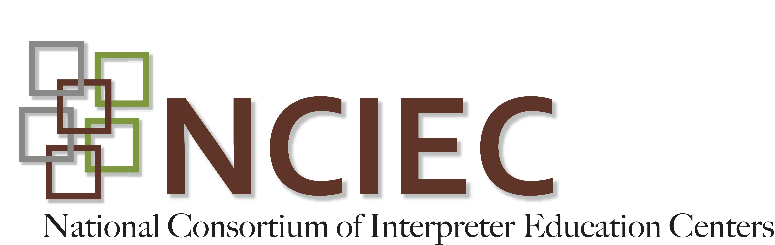
DEAF INTERPRETER-HEARING INTERPRETER TEAMS
Unit 4: DI-HI Team Preparation
Student Activity
The goal of this activity is for students to observe and analyze how a DI-HI team pre-conferences with each other before their work.
Film: “Deaf Interpreting: Team Strategies; Pre-Conference Discussion” (approximately 10 minutes long)
Setting: A DI-HI interpreting team is preparing to interpret a counseling session in a mental health setting. Before their work begins, they discuss a number of team-related strategies together.
Directions:
- Begin by viewing the introduction by Eileen Forestal to the Pre-Conference Discussion here: https://www.youtube.com/watch?v=vwPBSfwt670&list=PLmjvdaJRb2jWzcGG0NYF-61yLE81RYqe3&index=7

- After the brief introduction watch the actual pre-conferencing session between the DI and the HI and respond to the guiding questions below:
DI-HI Preconference Session
- What information does the DI share with the HI about the Deaf client?

- What feed target language does the team agree on?

- How does the DI say he will indicate if the feed from the HI is not clear?

- What cues does the team agree to use to indicate in-team communication?

- What does the DI specifically ask the HI to do in her feed to assist with information accuracy?

- When discussing the pace and flow of the feed interpretation, what does the team agree to do when the source message is extended beyond just a simple question?

- What does the DI suggest the HI do while the Deaf consumer is sharing comments and she is waiting for the DI’s interpretation of that content?

- How does the team agree to handle clarifications to the hearing or Deaf client from the DI-HI team?

- What does the team agree to do if the DI begins to “shadow” (copy exactly what the HI is feeding to the Deaf consumer)?

- How does the team agree to handle specific terms such as “legal guardian” and “native?”

