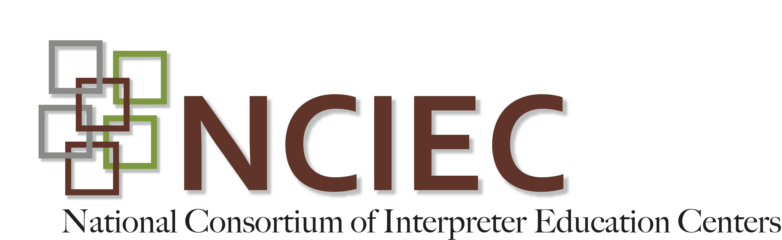
DeafBlind Interpreting Module
MODIFICATIONS TO YOUR INTERPRETING MODE

When working with persons who are DeafBlind, you will need to modify your mode of interpreting. Below you will find various interpreting modes that can used with Deaf persons who also have a significant vision loss. Some of these methods are used individually while others are used in combination. A consumer may also switch from one mode of receptive communication to another in the course of an assignment. When considering assignments involving persons who are DeafBlind , you can use these terms when inquiring about the consumer’s mode of communication.

- CLOSE VISION -
  - Close vision interpreting refers to a method used with Deaf and hard of hearing persons who rely on their residual vision for communication.
  - The interpreter positions themselves close to the consumer.
  - The interpreter also reduces their signing space and slows their rate of interpreting. With this method, the interpreter may sign just below their chin so the consumer can still lipread and see non-manual markers.
  - Fingerspelling should be slowed, taking care to lower the hand to chest level or move it to the shoulder area for maximum contrast between hand and clothing.
  - The interpreter should take consideration of the need to significantly narrow their signing space from side to side and top to bottom.
  - The distance of the interpreter from the DeafBlind person will depend on consumer preference.

- TRACKING -
  - Tracking is a method of communication utilized by DeafBlind persons who rely on their residual vision. This approach allows consumers to access sign language within their unique visual field.
  - With this method, the DeafBlind person will place one or both of their hands on the interpreter’s forearm(s) or wrist(s). Doing so allows the DeafBlind person to control the speed of the interpretation and keep the signs within their visual field.
  - This method is often used with persons who are losing their vision and transitioning to tactile sign language.

- TACTILE SIGN LANGUAGE -
  - Tactile sign language is a method used by persons who cannot access sign language through their vision. These persons will place one or two hands on top of the interpreter’s to receive the message.
  - The interpreter’s hand(s) should always be under those of the consumer.
  - In this method, the interpreter will sign at a pace allowing communication to occur comfortably.
  - Styles of Tactile Sign Language:
    - TWO-HANDED TACTILE METHOD - This mode is often embraced by individuals who have recently transitioned to tactile sign language. Hand positioning and placement will vary from consumer to consumer. Some consumers will prefer to place their hands directly on top of the interpreter’s so that the interpreter’s fingers are in their palms. Others prefer to place their hands at an angle over the interpreter’s knuckles. When the interpreter fingerspells, the consumer may slide their palms over to cup the interpreter’s fingers.
    - ONE-HANDED TACTILE METHOD - This method is typically used by individuals who are fluent signers, have experience with tactile reception and have been using this mode of communication for some time. Similar to the two-handed tactile method, the hand positioning and direction will vary depending on the consumer’s preference. One-handed sign language users may also temporarily utilize two-hands for clarity or to alleviate fatigue.

- PRINT-ON-PALM -
  - Print-on-Palm (POP) is a tactual method that allows consumers to receive letters, numbers or symbols in the palm of their hands.
  - The interpreter will use their index finger to trace words in the consumer’s hand, slightly pausing between each word.
  - The interpreter will trace block, capital letters except for "i" which is lower case. The letters are written on top of each other, not across the palm or onto the consumer's fingers.
  - In the event of an error, the interpreter will “erase” the error by wiping their hand across the consumer’s palm.
  - POP is used briefly to clarify a word, number, symbol or detail. It is usually used in conjunction with the other modes of communication described above.

Activity:
- Watch:
- “Modifications to Your Interpreting Mode”
- “Modifications to Mode – Close Vision and Tracking”

- Take the quiz:
  - “Quiz on Modes”.

Morgan, S. (n.d.). Interpreting strategies for deaf-blind students: An interactive training tool for educational interpreters. Dayton, OH: Ohio Center for Deaf-Blind Education. Retrieved (T200.0001.01)
Pro-Tactile Resources

PRO-TACTILE-The value of touch for the purposes of communication.

Pro-Tactile communication values the diversity in communication amongst Deaf persons. Some Deaf persons communicate via visual ASL while some communicate via touch. The videos found on www.protactile.org not only provide education they also provide examples of protactile communication.
- http://www.protactile.org/2016/03/pro-tactile-vlog-1.html
  - Vlog 1 introduces the meaning/value of PT. Attempts to clarify myths and misunderstandings.
- http://www.protactile.org/2016/03/english-transcription-of-aj-and-jelicas.html
  - Vlog 2 addresses backchanneling
- http://www.protactile.org/2016/03/pro-tactile-vlog-3.html
  - Vlog 3 clarifies differences between PT and Haptics
- http://www.protactile.org/2016/03/pro-tactile-vlog-4.html
  - Vlog 4 is about backchanneling
- http://www.protactile.org/2016/03/pro-tactile-vlog-5_14.html
  - Vlog 5 addresses PT philosophy and its support of the DeafBlind community, language, politics, etc.

