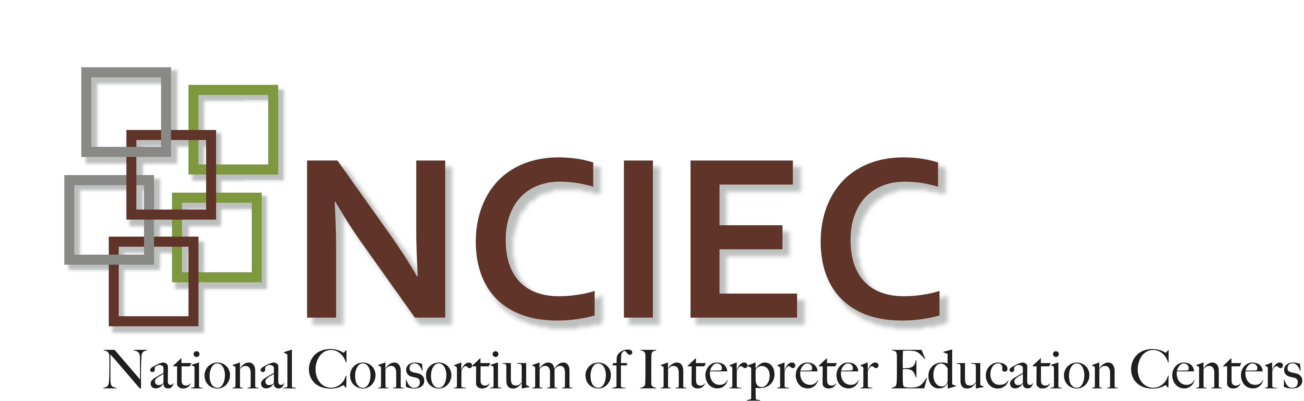
DeafBlind Interpreting Module
Modifications to Interpreting Mode

ANSWER KEY

Directions: Write the name of the interpreting mode next to its definition. You will use some modes more than once.

Tracking Two-Handed Tactile One-Handed Tactile Print-on-Palm Close Vision

- Print on Palm Used briefly to clarify a word, number, symbol or detail
- One-Handed Tactile Used by consumers who are very skilled at tactile communication
- Close Vision Involves greatly reducing your signing space
- Two-Handed Tactile Used when seeking fuller tactile picture of a signed message
- Close Vision and Tracking Used by persons with usable residual vision
- Two-Handed Tactile Used by persons just learning tactile sign
- Print-on-Palm Used in combination with both tactile modes
- Close Vision Involves reducing your rate of interpreting, particularly the speed of fingerspelling
- Tracking Often used as a transitional mode from visual to tactile communication
- Close Vision Only method that might be used while seated at a distance from the consumer.
Adapted by J. Hecker-Cain. Morgan, S. (n.d.). Interpreting strategies for deaf-blind students: An interactive training tool for educational interpreters. Dayton, OH: Ohio Center for Deaf-Blind Education. (T200.0001.01) Retrieved from the NCRTM website.

