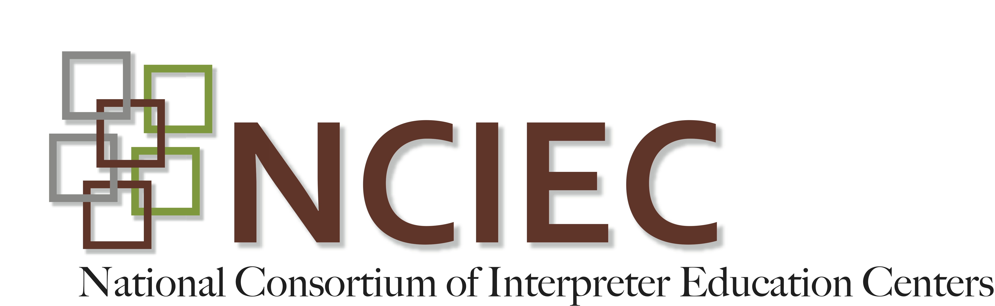
Deaf-Blind Interpreting Module
Student Guide to HKNC Conference Video
Below are annotations for the HKNC Conference Video. These will help you identify name signs and other information that will help you get the most out of this exercise.
Note: I is used for Interpreter; C for consumer
In the fall of 2011, the Helen Keller National Center for Deaf-Blind Youths and Adults in Sands Point, NY held a Technology Conference. An exemplary team of sign language interpreters was assembled to provide equal access to all participants and presenters.
The following was filmed in a single day at this conference. It captures multiple examples of the additional responsibilities that can go along with interpreting for Deaf-Blind people.
Throughout this video, you will be provided clues as to what to look for in the clip or clips that follow. For example, in the following, you’ll see examples of these additional responsibilities:
- Include the mood of the room
- Convey non-verbal comments
- Respect the consumer’s right to know everything
Interpreter (I) includes that the speaker is stuttering into the mic and smiling broadly.
I includes that Scott (name sign: S like MUSIC) is being blocked by the interpreter.
The consumer (C) asks the I if there is anything on the screen yet and the I replies NOT YET.

- Include the speaker’s name
- Include the people in the room and where they are in relation to your consumer
- Respect the consumer’s right to know everything
Sister Bernie, B like NUN, is talking.
D-O-R-I-S, woman sitting to your far right, will type all the information…
Scott is blocking the interpreters
Speaker cannot remember someone’s name
- Include the mood of the room
- Respect the consumer’s right to know everything
Speaker asks audience if they’re with her; Audience just stares back at speaker. (This happens twice in a row.)
Sr. Bernie sees someone in the back of the room and gives him/her a big hug.
C asks I if the presenters are still struggling with the technology; I replies yes and describes the screen
- Be ready to facilitate introductions
- Respect the consumer’s right to know everything
C asks for Deb H (name sign: DH on opposite shoulder) I calls her name.
I lets C know that Deb is chewing food.
I lets C know that Deb reacted to her telling him she was chewing food.
- Include the speaker’s name
I includes that D-A-V-I-D- has raised his hand to ask a question. And that DH is answering him.

- Learn or establish name signs for everyone involved
Bapin’s name sign (B like WOOD) is used early on. C is familiar with this name sign so no explanation is needed
I uses Scott’s name sign several times before C asks who that is. I clarifies Scott’s name sign.
- Respect the consumer’s right to know everything. Include the mood of the room
I lets C know that
- the voice feature is working on the screen.
- Doris just left the room through a door in the back.
- there is a man taking his picture.
- the audience is fascinated by what he is demonstrating.
- Include the people in the room and where they are in relation to your consumer.
- Introduce fingerspelling with care
- Convey non-verbal comments
I lets C know that the blind man who is sitting in the corner is David and that he reacted very excitedly to what C just demonstrated.
Note the slow speed of U-P-T-O-D-A-T-E.
I includes that audience member is smiling.
- Respect the consumer’s right to know everything
I lets C know that the interpreters are switching.
- Include the speaker’s name before you interpret what s/he is saying
I does not interpret the audience member’s question until she identifies herself by name. I keeps C informed throughout her exchange with the audience member.
- Include the mood of the room
Note that the presenter’s I reconnects with him to let him know that the audience is laughing loudly while the interpreter in the foreground does the same for her C.
I tells presenter to hold so she can convey Kevin’s (name sign: K at temple) question from the back of the room and includes the fact that Kevin is not serious (by the large size of his smile). The presenter teases Kevin and the teasing nature of the exchange is preserved.
- Be ready to facilitate introductions
I lets C know that DH is standing to his right and wants to talk to him.
- You may be expected to guide your consumer
Self-explanatory
- Respect the consumer’s right to know everything.
Note: the I conveys all of the C’s choices at the snack buffet table.
Note: the I guides the C’s hands to make her selections herself.
I includes the color of the pop-up on the screen.
I includes the fact that the program says “Good-bye” when it closes.
- Include the people in the room and where they are in relation to your consumer
- Introduce fingerspelling with care
I points to where learning stations are set up around the room; where DH is in relation to the C.
I described David and where he is sitting in relation to C and who is sitting next to him.
I describes D-E-O and where he is in relation to C and who is sitting next to him.
I identifies who is standing behind the C.

Describe the room
- Convey non-verbal comments
I lets C know there are participants standing by him waiting for him to get started that they are smiling.
- Be ready to facilitate introductions
- Include side comments
- Include non-verbal comments
Note how the interpreters handle the different communication styles in these group settings; how everyone is kept informed of everything that is happening around them.
- Respect consumer’s right to know everything
The I interprets an exchange about a participant’s guide dog, including detailed description of the dog’s physical appearance and who else is petting the dog and in what manner.
The I lets the C know who leaves the group and who joins.
I described the physical appearance of a woman who joins the group, right down to the color of her earrings.
- You may be expected to guide your consumer
Self-explanatory
- Include the speaker’s name before you interpret what s/he is saying
I clarifies the videographer’s name is Rob, not Bob.
- You may be expected to guide your consumer
Self-explanatory
- Respect consumer’s right to know everything
Note how the I relays all the C’s options at the HKNC “gift shop.”

