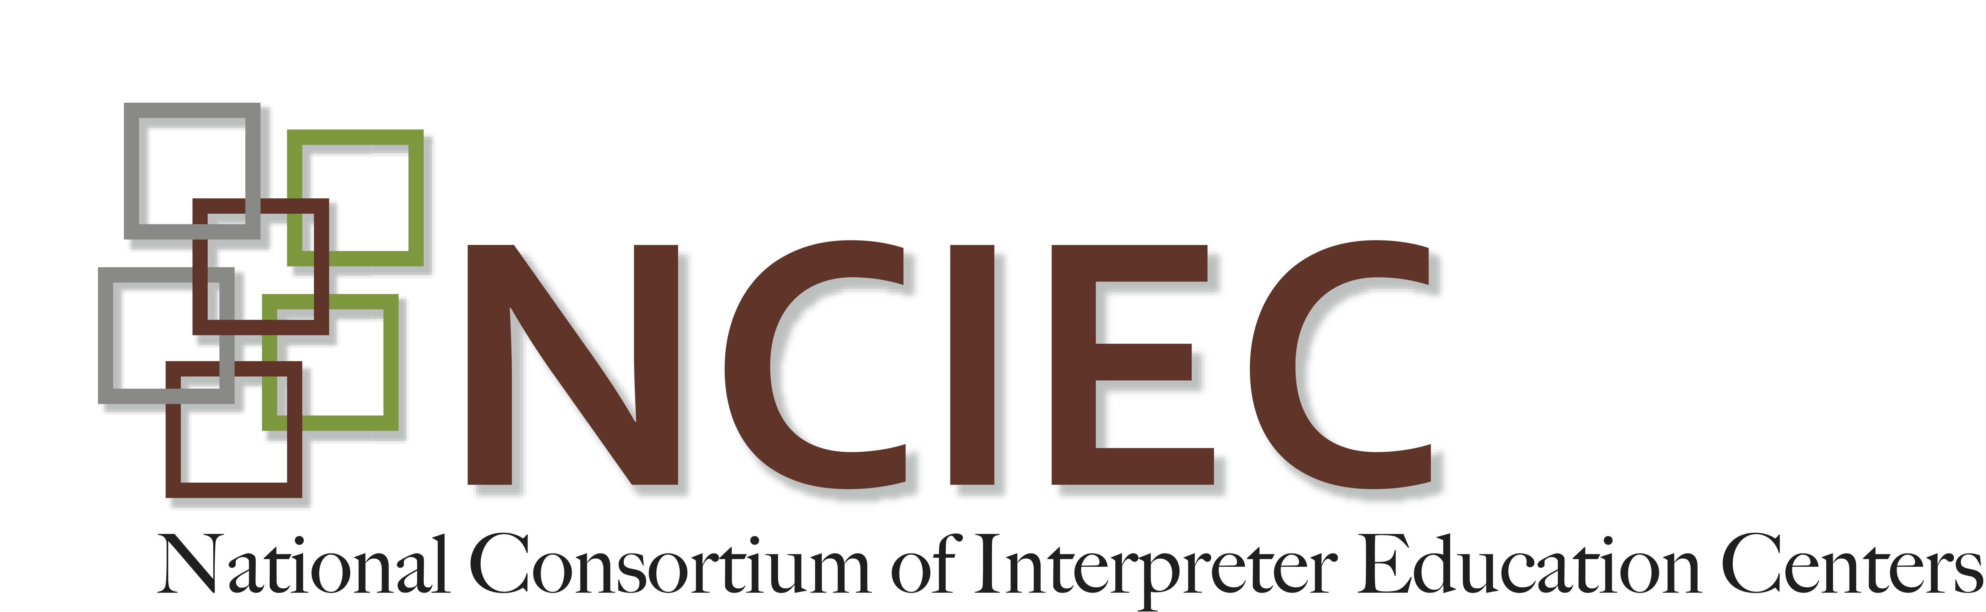
VR 101: History, System & Process

Understanding the VR Process
This presentation was developed as part of the instructional materials for Module 1: VR as a System, which is part of an online professional development series for VR interpreters hosted for the NCIEC by the University of Northern Colorado MARIE Center and is used here with permission. You may note reference to "insight". This term is used within the UNC and refers to a term used in their courses. It should be disregarded.
Any client who works with Vocational Rehabilitation services encounters a specific process that helps to determine the needs of the client and what supports should be put in place to provide for a positive vocational outcome. While the process may vary slightly from state to state, the general overall process is very similar.
This section focuses in on understanding this process so that interpreters can understand the big picture of how VR services work and how the specific step being interpreted fits into the larger picture.
This narrated PowerPoint presentation on the VR Process is 15 minutes in duration.
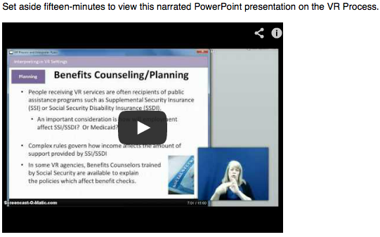
To view the presentation, click here: http://youtu.be/HxXa8imeVvw
ACTIVITY: After viewing this PPT, create a journal entry recording three aspects of the VR process that are new to you. Be sure to jot down any further questions you may have for further research.

